**Malaria Detection**

**INTRODUCTION**

Malaria is a life-threatening disease, It’s typically transmitted through the bite of an infected **anopheles mosquito**. Infected mosquitoes carry the **plasmodium parasite**. When this mosquito bites you, the parasite is released into your bloodstream. It is considered as an endemic in many parts of the world.

Malaria detection is performed by examining a drop of the patient’s blood, spread out as a “blood smear” (red blood cell) on a microscope slide. This blog focuses on improving malaria detection from such patches segmented from the microscopic images of blood smears by introducing a deep convolutional neural network. Compared to the traditional methods that use tedious hand engineering feature extraction, the proposed method uses deep learning in an end-to-end arrangement that performs both feature extraction and classification directly from the raw segmented patches of the red blood smears.

**SYMPTOMS OF MALARIA**

A malaria infection is generally characterized by the following signs and symptoms:

* Fever
* Chills
* Headache
* Nausea and vomiting
* Muscle pain and fatigue

Other signs and symptoms may include:

* Sweating
* Chest or abdominal pain
* Cough

**RISK FACTOR**

Malaria is commonly associated with poverty and has a major negative effect on economic development. In Africa, it is estimated to result in losses of **US$12 billion** a year due to increased healthcare costs, lost ability to work, and negative effects on tourism

**How is Malaria diagnosed by pathologists?**

Typically Malaria is diagnosed by microscopic examination of blood cells under the supervision of a pathologist. Red blood cells are examined using a microscope using blood films. The pathologists try to find evidence of Malaria using past domain knowledge. Typically, when a cell is infected with Malaria one can see distorted cell shapes which are also accompanied by certain blunt spots in the cell.

**PROBLEM STATEMENT**

For malaria as well as other microbial infections, manual inspection of thick and thin blood smears by trained microscopists remains the gold standard for parasite detection and stage determination because of its low reagent and instrument cost and high flexibility. Despite manual inspection being extremely low throughout and susceptible to human bias, automatic counting software remains largely unused because of the wide range of variations in brightfield microscopy images. However, a robust automatic counting and cell classification solution would provide enormous benefits due to faster and more accurate quantitative results without human variability; researchers and medical professionals could better characterize stage-specific drug targets and better quantify patient reactions to drugs.

**General Outline**

**Our code template shall perform the following steps:**

1. Importing Libraries
2. Preliminary Data Processing.
3. Check the total number of entries
4. Exploratory Data Analysis (EDA).

**Importing Libraries**

import os

import random

import tensorflow as tf

from tensorflow.keras.layers import Input, Lambda, Dense, Flatten,Conv2D

from tensorflow.keras.models import Model

from tensorflow.keras.applications.vgg19 import VGG19

from tensorflow.keras.applications.resnet50 import preprocess_input

from tensorflow.keras.preprocessing import image

from tensorflow.keras.preprocessing.image import ImageDataGenerator,load_m g

from tensorflow.keras.models import Sequential

import numpy as np

from glob import glob

import matplotlib.pyplot as plt

**Preliminary Data Processing**

To start off, we read in our dataset.

##Directory for Parasitized cell images</br>

IMAGE_SIZE = [224, 224]

train_path = '/content/drive/MyDrive/Dataset/Train'

valid_path = '/content/drive/MyDrive/Dataset/Test'

# create a model object

model = Model(inputs=mobilnet.input, outputs=prediction)

model.summary()

from tensorflow.keras.layers import MaxPooling2D

### Create Model from scratch using CNN

model=Sequential()

model.add(Conv2D(filters=16,kernel_size=2,padding="same",activation="relu",input_shape=(224,224,3)))

model.add(MaxPooling2D(pool_size=2))

model.add(Conv2D(filters=32,kernel_size=2,padding="same",activation ="relu"))

model.add(MaxPooling2D(pool_size=2))

model.add(Conv2D(filters=64,kernel_size=2,padding="same",activation="relu"))

model.add(MaxPooling2D(pool_size=2))

model.add(Flatten())

model.add(Dense(500,activation="relu"))

model.add(Dense(2,activation="softmax"))

model.summary()

**Step2. Exploratory Data Analysis(EDA)**

**Parasitized Images**

import matplotlib.pyplot as plt

from matplotlib.image import imread

import seaborn as sns

import random

import os

filenames = random.sample(os.listdir('/content/drive/MyDrive/Dataset/Train/Parasite') , 25)

##here we will see 25 images of Parasitized cell images

plt.figure(figsize=(15, 15))  # figure size

for i in range(1, len(filenames)):

    row = i

    image = imread('/content/drive/MyDrive/Dataset/Train/Parasite/' + filenames[i])

    plt.subplot(5, 5, row)

    plt.imshow(image)

plt.show()

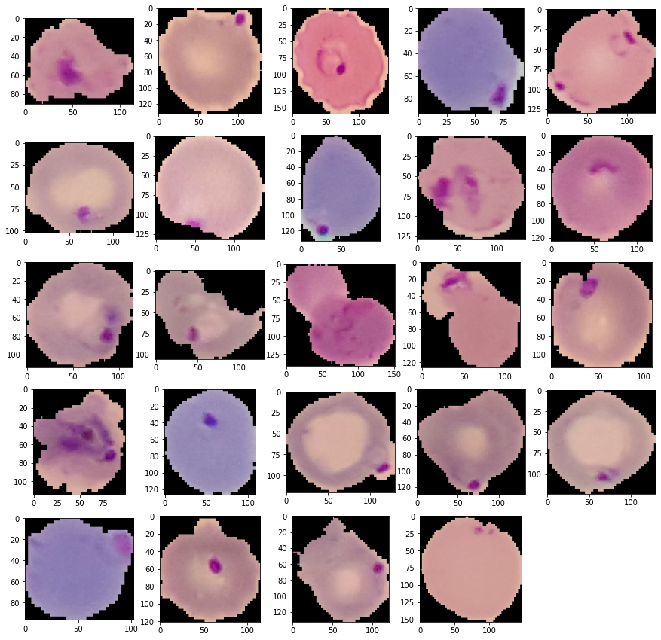

from tensorflow.keras.models import load_model

model.save('model_vgg19.h5')

y_pred = model.predict(test_set)

import numpy as np

y_pred = np.argmax(y_pred, axis=1)

y_pred